## REDME FILE##

**Technology used :**

* Front-end = react.js
* Backend =springboot

**Ide used :**

* Vs code
* Intellij ide

**Output shronshoot of UI :**

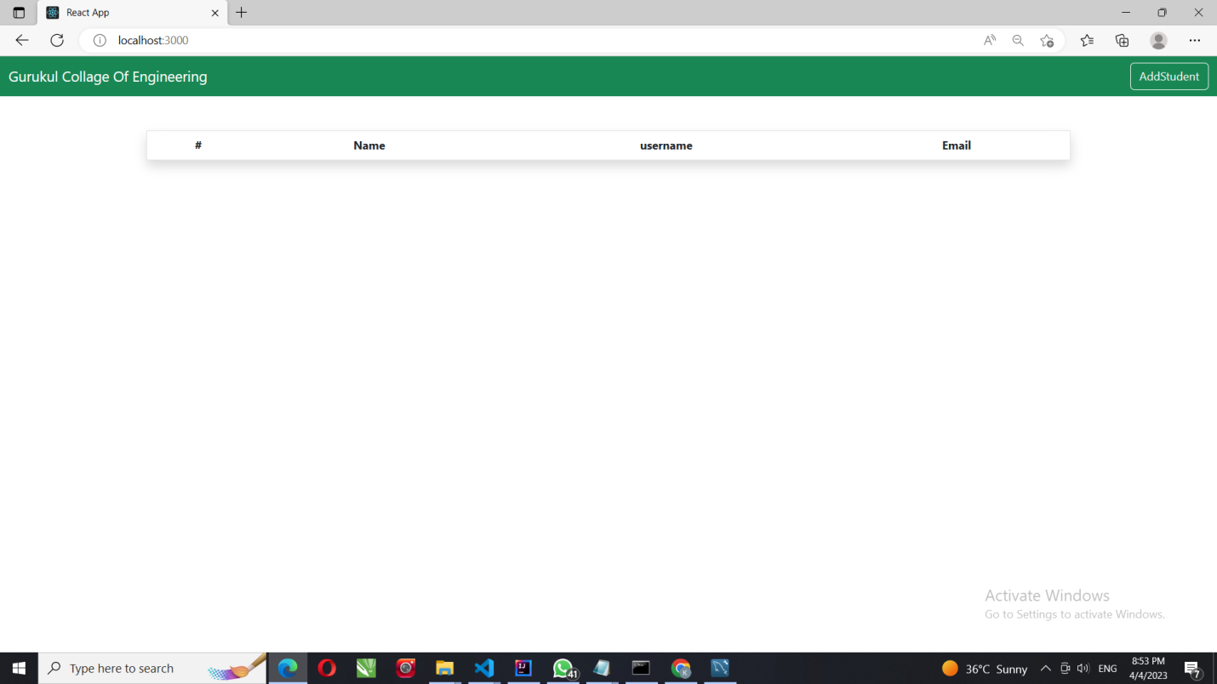

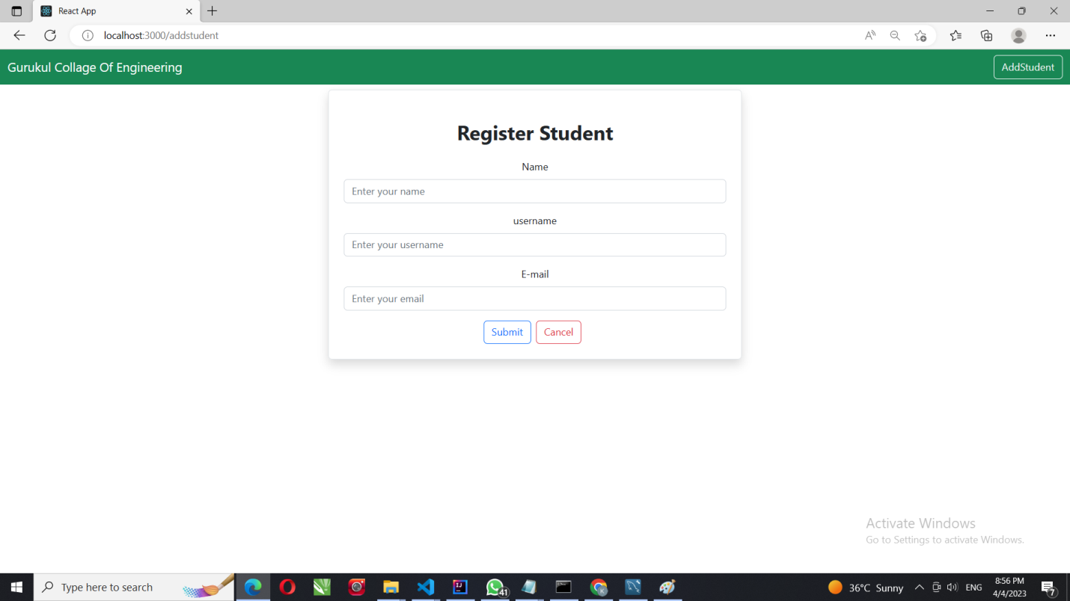

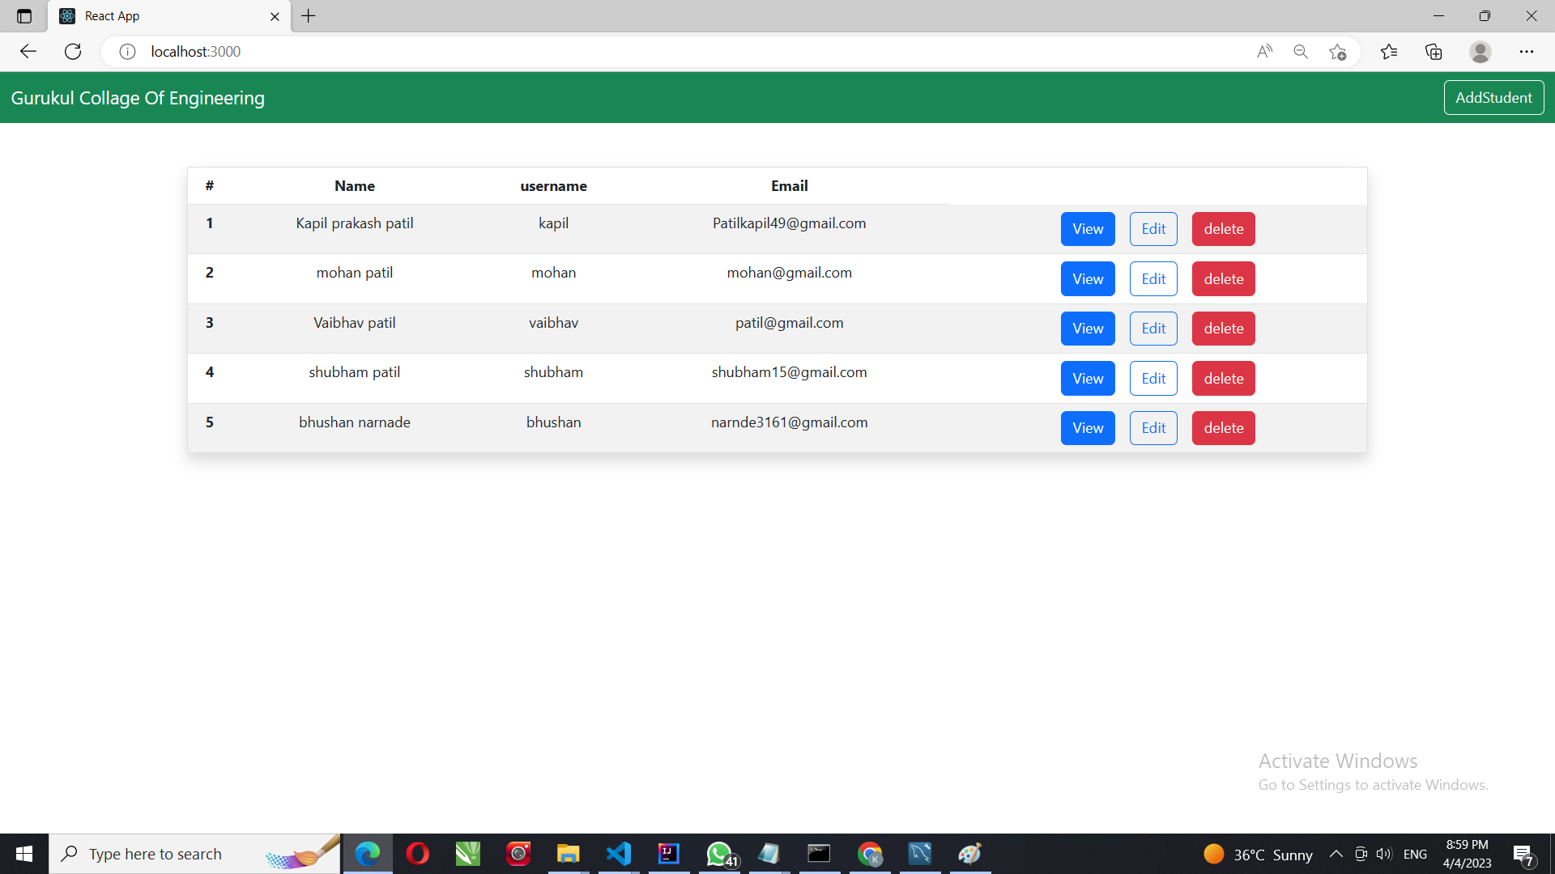

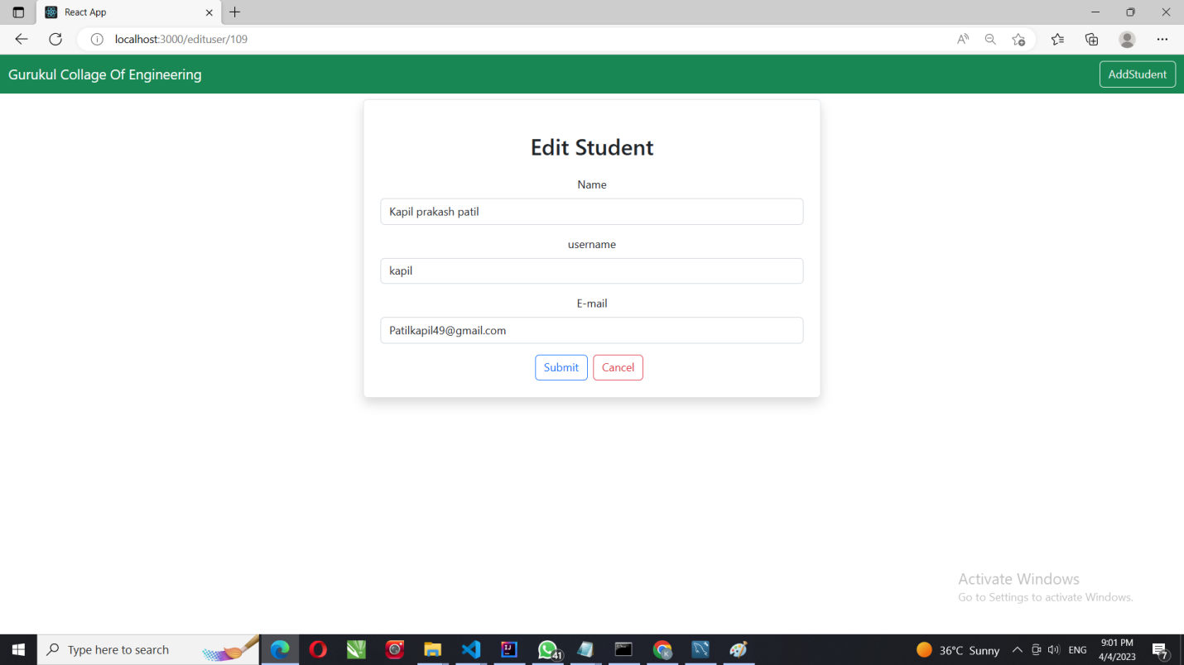

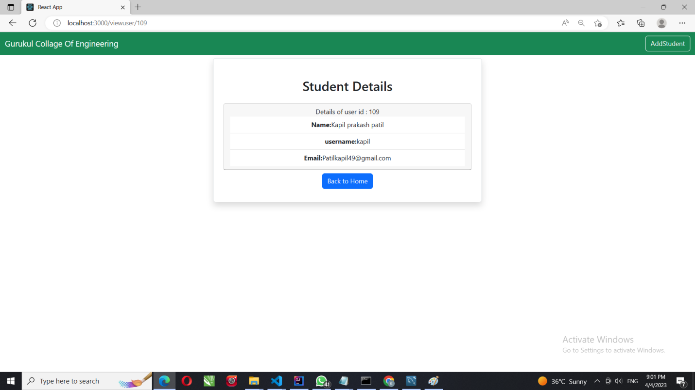

**DELETE STUDENT FORM PORTAL**

